**Chapter 10 – Overview of Busses**

This chapter contains some important material that is often overlooked in textbooks; indeed, it   
has been overlooked in every previous edition of this textbook. Computer busses form the   
topic of this chapter, which shall focus on issues common to the design of all data busses while   
mentioning specific data bus types as illustrations. Other chapters, specifically those on   
memory, the CPU, and the I/O system will discuss the details of a bus as it applies to each of   
those design areas. The reader should note that this chapter will contain some material that is   
duplicative of that found in the other chapters; this is intentional.

A typical computer contains a number of busses, at various levels. As we shall see in a later chapter, the CPU (Central Processing Unit) contains internal busses that are used to connect the ALU (Arithmetic Logic Unit) with the register file, as well as with other internal registers. This chapter will focus on the other busses in the computer, as they present design issues not seen in the CPU internal busses. The top–level logical architecture is as follows.

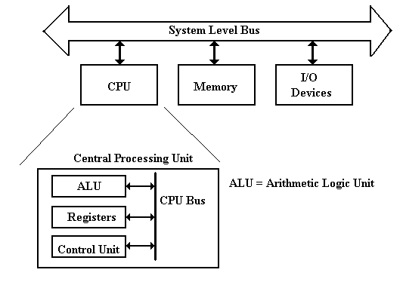

As noted above, the topics for this chapter focus on those busses that are outside of the CPU. As we shall see, some early designs, such as the PDP–11 from the 1970’s, had only one bus external to the CPU. We shall see the bus structure evolve in response to commercial pressures.

**Reality Intrudes**

The design on the previous slide is logically correct, but it no longer represents the actual organization of any modern commercial computers. The problem is that the bus cannot handle the work load associated with modern computers, especially the requirement for fast access to memory and intense data rates to the graphics card.

Here is a refinement of the above diagram. We now have two fast busses, one each for the graphics card and the memory. I/O devices are relegated to the system bus.



This design is getting closer to reality.

We now turn to commercial realities, specifically **legacy I/O devices**. When upgrading a computer, most users do not want to buy all new I/O devices (expensive) to replace older devices that still function well. The I/O system must provide a number of busses of different speeds, addressing capabilities, and data widths, to accommodate this variety of I/O devices.



Here we show the main I/O bus connecting the CPU to the **I/O Control Hub** (ICH), which is connected to two I/O busses: one for slower (older) devices  
 one for faster (newer) devices.

The requirement to handle memory as well as a proliferation of I/O devices has lead to a new design based on two controller hubs:

1. The Memory Controller Hub or “North Bridge”

2. The I/O Controller Hub or “South Bridge”

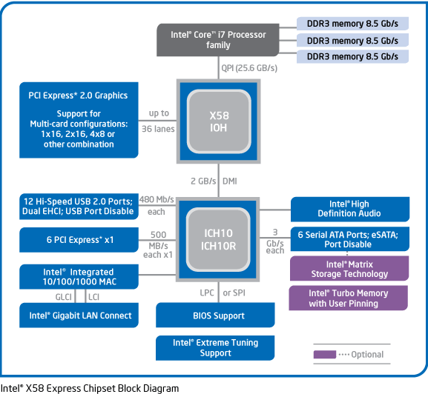

Such a design allows for grouping the higher–data–rate connections on the faster controller, which is closer to the CPU, and grouping the slower data connections on the slower controller, which is more removed from the CPU. The names “Northbridge” and “Southbridge” come from analogy to the way a map is presented. In almost all chipset descriptions, the Northbridge is shown above the Southbridge. In almost all maps, north is “up”.

It is worth note that, in later designs, much of the functionality of the Northbridge has been moved to the CPU chip.

**Backward Compatibility in System Buses**

The early evolution of the Intel microcomputer line provides an interesting case study in the effect of commercial pressures on system bus design. We focus on three of the earliest models, the Intel 8086, Intel 80286, and Intel 80386. All three had 16–bit data lines.  
 The Intel 8086 had a 20–bit address line. It could address 1 MB of memory.  
 The Intel 80286 had a 24–bit address line. It could address 16 MB of memory.  
 The Intel 80386 had a 32–bit address line. It could address 4 GB of memory.

Here is a figure showing the growth of the address bus structure for these three designs. Note that an old style (Intel 8086) bus interface card could be inserted into the 20–bit slot of either the Intel 80286 or Intel 80386, and still function normally. The Intel 80286 interface, with its 24 bits of address split into two parts, could fit the 24–bit (20 bits and 4 bits) slot of the Intel 80386.

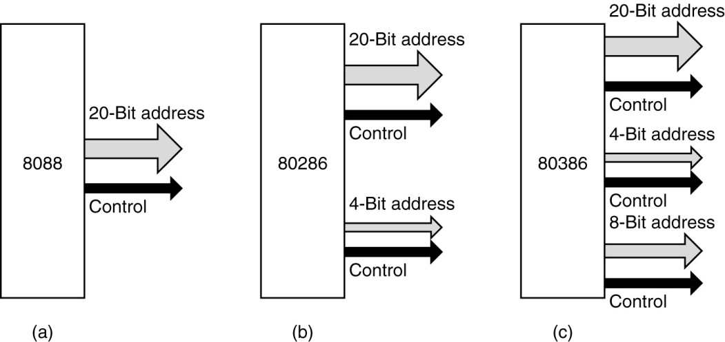

The Intel 80286 was marketed as the IBM PC/AT (Advanced Technology). Your author fondly remembers his PC/AT from about 1986; it was his first computer with a hard disk (40 MB).

**Detour: The IBM Micro–Channel Bus**

The Micro–Channel Architecture was a proprietary bus created by IBM in the 1980’s for use on their new PS/2 computers. It was first introduced in 1987, but never became popular. Later, IBM redesigned most of these systems to use the PCI bus design (more on this later). The PS/2 line was seen by IBM as a follow–on to their PC/AT line, but was always too costly, typically selling at a premium. In 1990, the author of this textbook was authorized to purchase a new 80386–class computer for his office. The choice was either an IBM MCA unit or a PC clone. This was put out for bids. When the bids were received, the lowest IBM price was over $5,000, while a compatible PC of the same power was $2,900.

According to Wikipedia

“Although MCA was a huge technical improvement over ISA, its introduction and marketing by IBM was poorly handled. IBM did not develop a peripheral card market for MCA, as it had done for the PC. It did not offer a number of peripheral cards that utilized the advanced bus-mastering and I/O processing capabilities of MCA. Absent a pattern, few peripheral card manufacturers developed such designs on their own. Consequently customers were not provided many advanced capabilities to justify the purchase of comparatively more expensive MCA systems and opted for the plurality of cheaper ISA designs offered by IBM's competition.”

“IBM had patents on MCA system features and required MCA system manufacturers to pay a license fee. As a reaction to this, in late 1988 the "Gang of Nine", led by Compaq, announced a rival bus – EISA. Offering similar performance benefits, it had the advantage of being able to accept older XT and ISA boards.”

“MCA also suffered for being a proprietary technology. Unlike their previous PC bus design, the AT bus, IBM did not publicly release specifications for MCA and actively pursued patents to block third parties from selling unlicensed implementations of it, and the developing PC clone market did not want to pay royalties to IBM in order to use this new technology. The PC clone makers instead developed EISA as an extension to the existing old AT bus standard. The 16–bit AT bus was embraced and renamed as ISA to avoid IBM's "AT" trademark. With few vendors other than IBM supporting it with computers or cards, MCA eventually failed in the marketplace.”

“While EISA and MCA battled it out in the server arena, the desktop PC largely stayed with ISA up until the arrival of PCI, although the VESA Local Bus, an acknowledged stopgap, was briefly popular.” [R92]

**Notations Used for a Bus**

We pause here in our historical discussion of bus design to introduce a few terms used to characterize these busses. We begin with some conventions used to draw busses and their timing diagrams. Here is the way that we might represent a bus with multiple types of lines.

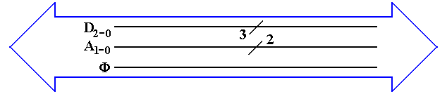

The big “double arrow” notation indicates a bus of a number of different signals. Some authors call this a “fat arrow”. Lines with similar function are grouped together. Their count is denoted with the “diagonal slash” notation. From top to bottom, we have  
 1. Three data lines D2, D1, and D0  
 2. Two address lines A1 and A0  
 3. The clock signal for the bus Φ.  
 Not all busses transmit a clock signal; the system bus usually does.

Power and ground lines usually are not shown in this type of diagram. Note the a bus with only one type of signal might be drawn as a thick line with the slash, as in the 3 – bit data bus above.

Maximum Bus Length

In general, bus length varies inversely as transmission speed, often measured in Hz; e.g., a   
1 MHz bus can make one million transfers per second and a 2 GHz bus can make two billion.   
Immediately we should note that the above is not exactly true of DDR (Double Data Rate) busses which transfer at twice the bus speed; a 500 MHz DDR bus transfers 1 billion times a second.  
Note that the speed in bytes per second is related to the number of bytes per transfer. A DDR bus rated at 400 MHz and having 32 data lines would transfer 4 bytes 800 million times a second, for a total of 3.20 billion bytes per second. Note that this is the peak transfer rate.

The relation of the bus speed to bus length is due to signal propagation time. The speed of light is approximately 30 centimeters per nanosecond. Electrical signals on a bus typically travel at   
2/3 the speed of light; 20 centimeters per nanosecond or 20 meters per microsecond.

A loose rule of thumb in sizing busses is that the signal should be able to propagate the entire length of the bus twice during one clock period. Thus, a 1 MHz signal would have a one microsecond clock period, during which time the signal could propagate no more than twenty meters. This length is a round trip on a ten meter bus; hence, the maximum length is 10 meters. Similarly, a 1 GHz signal would lead to a maximum bus length of ten centimeters.

The rule above is only a rough estimator, and may be incorrect in some details. Since the typical bus lengths on a modern CPU die are on the order of one centimeter or less, we have no trouble.

Bus Classifications

It should be no surprise that, depending on the feature being considered, there are numerous ways to characterize busses. We have already seen one classification, what might be called a “mixed bus” vs. a “pure bus”; i.e., does the bus carry more than one type of signal. Most busses are of the mixed variety, carrying data, address, and control signals. The internal CPU busses on our design carry only data because they are externally controlled by the CPU Control Unit that sends signals directly to the bus end points.

One taxonomy of busses refers to them as either point–to–point vs. shared. Here is a picture of that way of looking at busses.



An example of a **point–to–point** bus might be found in the chapter on computer internal memory, where we postulated a bus between the MBR and the actual memory chip set. Most commonly, we find **shared busses** with a number of devices attached.

Another way of characterizing busses is by the number of “bus masters” allowed. A **bus master** is a device that has circuitry to issue command signals and place addresses on the bus. This is in distinction to a “**bus slave**” (politically incorrect terminology) that can only transfer data in response to commands issued by a bus master. In the early designs, only the CPU could serve as a bus master for the memory bus. More modern memory busses allow some input/output devices (discussed later as DMA devices) to act as bus masters and transfer data to the memory.

Bus Clocks

Another way to characterize busses is whether the bus is asynchronous or synchronous. A **synchronous bus** is one that has one or more clock signals associated with it, and transmitted on dedicated clock lines. In a synchronous bus, the signal assertions and data transfers are coordinated with the clock signal, and can be said to occur at predictable times.

An **asynchronous** bus is one without a clock signal. The data transfers and some control signal assertions on such a bus are controlled by other control signals. Such a bus might be used to connect an I/O unit with unpredictable timing to the CPU. The I/O unit might assert some sort of **ready** signal when it can undertake a transfer and a **done** signal when the transfer is complete.

In order to understand these busses more fully, it would help if we moved on to a discussion of the bus timing diagrams and signal levels.

Bus Signal Levels

Many times bus operation is illustrated with a timing diagram that shows the value of the digital signals as a function of time. Each signal has only two values, corresponding to logic 0 and to logic 1. The actual voltages used for these signals will vary depending on the technology used.

A bus signal is represented in some sort of trapezoidal form with rising edges and falling edges, neither of which is represented as a vertical line. This convention emphasizes that the signal cannot change instantaneously, but takes some time to move between logic high and low. Here is a depiction of the bus clock, represented as a trapezoidal wave.

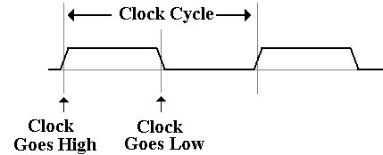

Here is a sample diagram, showing two hypothetical discrete signals. Here the discrete signal B# goes low during the high phase of clock T1 and stays low. Signal A# goes low along with the second half of clock T1 and stays low for one half clock period.



A collection of signals, such as 32 address lines or 16 data lines cannot be represented with such a simple diagram. For each of address and data, we have two important states; the signals are valid, and signals are not valid

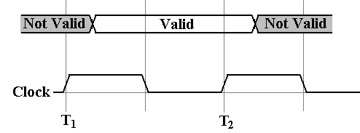

For example, consider the address lines on the bus. Imagine a 32–bit address. At some time after T1, the CPU asserts an address on the address lines. This means that each of the 32 address lines is given a value, and the address is valid until the middle of the high part of clock pulse T2, at which the CPU ceases assertion.

Having seen these conventions, it is time to study a pair of typical timing diagrams. We first study the timing diagram for a synchronous bus. Here is a read timing diagram.

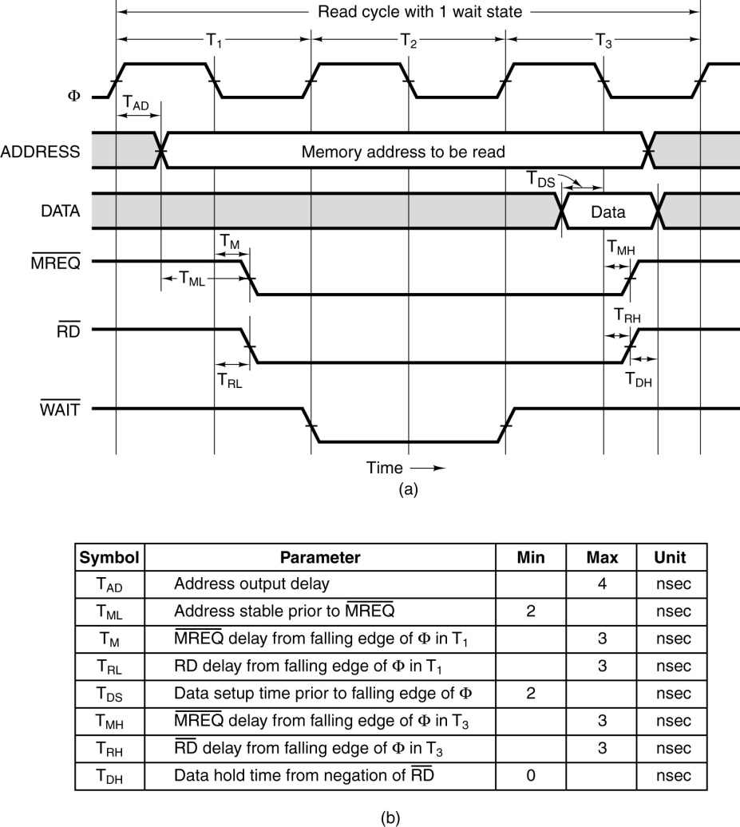

What we have here is a timing diagram that covers three full clock cycles on the bus. Note that during the high clock phase of T1, the address is asserted on the bus and kept there until the low clock phase of T3. Before and after these times, the contents of the address bus are not specified. Note that this diagram specifies some timing constraints. The first is TAD, the maximum allowed delay for asserting the address after the clock pulse if the memory is to be read during the high phase of the third clock pulse.

Note that the memory chip will assert the data for one half clock pulse, beginning in the middle of the high phase of T3. It is during that time that the data are copied into the MBR.

Note that the three control signals of interest (  ) are asserted low. We also have another constraint TML, the minimum time that the address is stable before the  is asserted.

The purpose of the diagram above is to indicate what has to happen and when it has to happen in order for a memory read to be successful via this synchronous bus. We have four discrete signals (the clock and the three control signals) as well as two multi–bit values (memory address and data).

For the discrete signals, we are interested in the specific value of each at any given time. For the multi–bit values, such as the memory address, we are only interested in characterizing the time interval during which the values are validly asserted on the data lines.

Note that the more modern terminology for the three control signals that are asserted low would be **MREQ#**, **RD#**, and **WAIT#**.

The timing diagram for an asynchronous bus includes some additional information. Here the focus is on the protocol by which the two devices interact. This is also called the “handshake”. The bus master asserts MSYN# and the bus slave responds with SSYN# when done.

The asynchronous bus uses similar notation for both the discrete control signals and the   
multi–bit values, such as the address and data. What is different here is the “causal arrows”, indicating that the change in one signal is the causation of some other event. Note that the assertion of **MSYN#** causes the memory chip to place data on the bus and assert **SSYN#**. That assertion causes **MSYN#** to be dropped, data to be no longer asserted, and then **SSYN#** to drop.

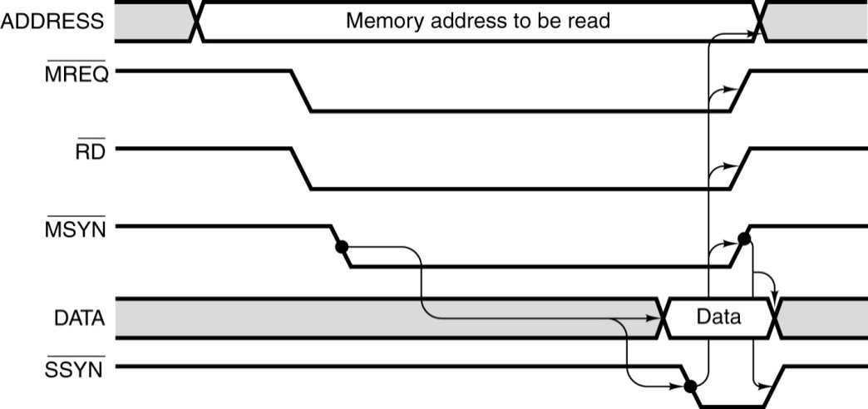

**Multiplexed Busses**

A bus may be either multiplexed or non–multiplexed. In a **multiplexed bus**, bus data and address share the same lines, with a control signal to distinguish the use. A **non–multiplexed** bus has separate lines for address and data. The multiplexed bus is cheaper to build in that it has fewer signal lines. A non–multiplexed bus is likely faster.

There is a variant of multiplexing, possibly called “**address multiplexing**” that is seen on most modern memory busses. In this approach, an N–bit address is split into two (N/2)–bit addresses, one a row address and one a column address. The addresses are sent separately over a dedicated address bus, with the control signals specifying which address is being sent.

Recall that most modern memory chips are designed for such addressing. The strategy is to specify a row, and then to send multiple column addresses for references in that row. Some modern chips transmit in burst mode, essentially sending an entire row automatically.

Here, for reference, is the control signal description from the chapter on internal memory.

|  |  |  |  |  |
| --- | --- | --- | --- | --- |
| **CS#** | **RAS#** | **CAS#** | **WE#** | **Command / Action** |
| 1 | d | d | d | Deselect / Continue previous operation |
| 0 | 1 | 1 | 1 | NOP / Continue previous operation |
| 0 | 0 | 1 | 1 | Select and activate row |
| 0 | 1 | 0 | 1 | Select column and start READ burst |
| 0 | 1 | 0 | 0 | Select column and start WRITE burst |

**More on Real Bus Architecture**

Here we offer some information on a now–obsolete bus of some historical interest. For those that are not interested in the history, we note that this presents a chance to discuss some issues related to bus design that have not yet been broached.

The bus in question is the PDP–11 Unibus™, manufactured in the 1970’s by the Digital Equipment Corporation. We first discuss the use of ground lines. Ground lines on the bus have two purposes   
 1. to complete the electrical circuits, and   
 2. to minimize cross–talk between the signal lines.

Cross–talk occurs when a signal on one bus line radiates to and is copied by another bus line. Placing a ground line between 2 lines minimizes this. This small bus is modeled on the Unibus.

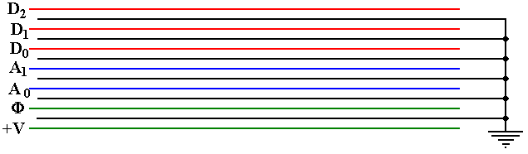

The variety of signals that can be placed on a bus is seen in the following table adapted from the PDP-11 Peripherals Handbook [R3]. Note that this bus operates as an asynchronous bus, which will allow slower I/O devices to use the bus.

|  |  |  |  |  |
| --- | --- | --- | --- | --- |
| **Name** | **Mnemonic** | **Lines** | **Function** | **Asserted** |
| TRANSFER LINES |  |  |  |  |
| Address | A<17:00> | 18 | Selects device or memory | Low |
| Data | D<15:00> | 16 | Data for transfer | Low |
| Control | C0, C1 | 2 | Type of data transfer | Low |
| Master Sync | MSYN | 1 | Timing controls for data transfer | Low |
| Slave Sync | SSYN | 1 | Low |
| Parity | PA, PB | 2 | Device parity error | Low |
| Interrupt | INTR | 1 | Device interrupt | Low |
| PRIORITY LINES |  |  |  |  |
| Bus Request | BR4, BR5, BR6, BR7 | 4 | Requests use of bus | Low |
| Bus Grant | BG4, BG5, BG6, BG7 | 4 | Grants use of bus | High |
| Selection Acknowledge | SACK | 1 | Acknowledges grant | Low |
| Bus Busy | BBSY | 1 | Data section in use | Low |
| INITIALIZATION |  |  |  |  |
| Initialize | INIT | 1 | System Reset | Low |
| AC Low | AC LO | 1 | Monitor power | Low |
| DC Low | DC LO | 1 | Monitor power | Low |

**Figure: PDP-11 UNIBUS CONTROL SIGNALS**

We see above the expected data and address lines, though noting the small address size. We see most of the expected control lines (MSYN# and SSYN#). What about the priority lines? These are control lines that allow an I/O device to signal the CPU that it is ready to transfer data.

The Boz series of computer designs follows the PDP–11 model in that it has four priority levels for I/O devices. While this strategy will be discussed more fully in a future chapter, we note here that the bus used for the I/O devices to communicate with the CPU must have two lines for each level in order for the interrupt structure to function.

The above figure suggests that the PDP–11 can operate in one of eight distinct priority levels, from 0 to 7. The upper four levels (4, 5, 6, and 7) are reserved for handling I/O devices. The lower four levels (0, 1, 2, and 3) were probably never fully implemented. Normal programs run at priority 0, and the other three levels (1, 2, and 3) are probably ignored. At each level, the bus provides two lines: BR (bus request) that is the interrupt line, and BG (bus grant) that signals the device to start transferring data. As indicated above, we shall say more on this very soon.

**Modern Computer Busses**

The next major step in evolution of the computer bus took place in 1992, with the introduction by Intel of the PCI (Peripheral Component Interconnect) bus. By 1995, the bus was operating at 66 MHz, and supporting both a 32–bit and 64–bit address space.

According to Abbott [R64], “PCI evolved, at least in part, as a response to the shortcomings of the then venerable ISA bus. … ISA began to run out of steam in 1992, when Windows had become firmly established.” Revision 1 of the PCI standard was published in April 1993.

The PCI bus standard has evolved into the PCI Express standard, which we shall now discuss.

**PCI Express**

PCI Express (Peripheral Component Interconnect Express) is a computer expansion card standard designed to replace the older PCI bus standard. The name is abbreviated as “PCIe”. This is viewed as a standard for computer expansion cards, but really is a standard for the communication link by which a compliant device will communicate over the bus.

According to Wikipedia [R93], PCIe 3.0 (August 2007) is the latest standard. While an outgrowth of the original PCI bus standard, the PCIe is not compatible with that standard at the hardware level. The PCIe standard is based on a new protocol for electrical signaling.  
This protocol is built on the concept of a lane, which we must define. A PCI connection can comprise from 1 to 32 lanes. Here are some capacity quotes from Wikipedia

Per Lane 16–Lane Slot  
Version 1 250 MB/s 4 GB/s  
Version 2 500 MB/s 8 GB/s  
Version 3 1 GB/s 16 GB/s

**What is a Lane?**

A lane is pair of point–to–point serial links, in other words the lane is a full–duplex link, able to communicate in two directions simultaneously. Each of the serial links in the pair handles one of the two directions.

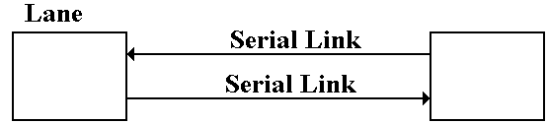

By definition, a **serial link** transmits one bit at a time. By extension, a **lane** may transmit two bits at any one time, one bit in each direction. One may view a **parallel link**, transmitting multiple bits in one direction at any given time, as a collection of serial links. The only difference is that a parallel link must provide for synchronization of the bits sent by the individual links.

**Data Transmission Codes**

The PCIe standard is byte oriented, in that it should be viewed logically as a full–duplex byte stream. What is actually transmitted? The association of bits (transmitted or received) with bytes is handled at the Data Link layer. Suppose a byte is to be transmitted serially.

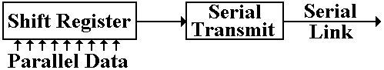

The conversion from byte data to bit–oriented data for serial transmission is done by a shift register. The register takes in eight bits at a time and shifts out one bit at a time. The bits, as shifted out, are still represented in standard logic levels. The serial transmit unit takes the standard logic levels as input, and converts them to voltage levels appropriate for serial transmission.

**Three Possible Transmission Codes**

The serial transmit unit sends data by asserting a voltage on the serial link. The simplest method would be as follows.  
 To transmit a logic 1, assert +5 volts on the transmission line.  
 To transmit a logic 0, assert 0 volts on the transmission line.

There are very many problems with this protocol. It is not used in practice for any purpose other than transmitting power. The two main difficulties are as follows. The first problem is that of transmitting power. If the average voltage (over time) asserted by a transmitter on a line is not zero, then the transmitter is sending power to the receiver. This is not desirable. The answer to this is to develop a protocol such that the time–averaged voltage on the line is zero. Such a protocol might call for enough changes in the voltage level to allow for data framing. Standard methods for link management use codes that avoid these problems. Two of the more common methods used are NRZ and NRZI.

**Non–Return–to–Zero** coding transmits by asserting the following voltages:  
 For a logic 1, it asserts a positive voltage (3.0 – 5.0 volts) on the link.  
 For a logic 0, it asserts a negative voltage (–3.0 to –5.0 volts).

**Non–Return–to–Zero–Invert** is a modification of NRZ, using the same  
voltage levels.

**The Problem of Noise**

One problem with these serial links is that they function as antennas. They will pick up any stray electromagnetic radiation if in the radio range.

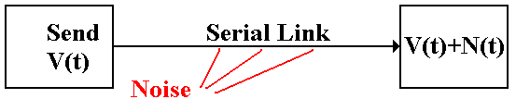

In other words, the signal received at the destination might not be what was actually transmitted. It might be the original signal, corrupted by noise. The solution to the problem of noise is based on the observation that two links placed in close proximity will receive noise signals that are almost identical. To make use of this observation, we use **differential transmitters** [ R94]to send the signals and **differential receivers** to reconstruct the signals.

In differential transmission, rather than asserting a voltage on a single output line, the transmitter asserts two voltages: +V/2 and –V/2. A +6 volt signal would be asserted as two: +3 volts and –3 volts. A –8 volt signal would be asserted as two: –4 volts and +4 volts.

Here are the standard figures for a differential transmitter and differential receiver. The standard receiver is an analog subtractor, here giving V/2 – (–V/2) = V.



**Differential Transmitter Differential Receiver**

**Noise in a Differential Link**

We now assume that the lines used to transmit the differential signals are physically close together, so that each line is subject to the same noise signal.

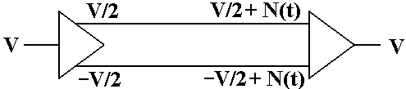

Here the received signal is the difference of the two voltages input to the differential receiver. The value received is ( V/2 +N(t) ) – ( –V/2 + N(t) ) = V, the desired value.

**Ground Offsets in Standard Links**

All voltages are measured relative to a standard value, called **“ground”**. Here is the complete version of the simple circuit that we want to implement.

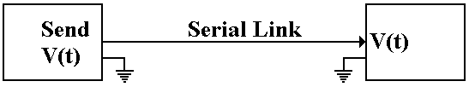

Basically, there is an assumed second connection between the two devices. This second connection fixes the zero level for the voltage.

There is no necessity for the two devices to have the same ground. Suppose that the ground for the receiver is offset from the ground of the transmitter.

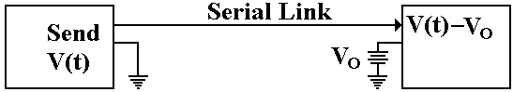

The signal sent out as +V(t) will be received as V(t) – VO. Here again, the subtractor in the differential receiver handles this problem.

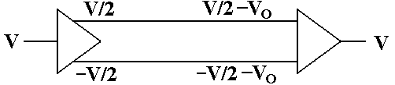

The signal originates as a given voltage, which can be positive, negative, or 0. The signal is transmitted as the pair (+V/2, –V/2). Due to the ground offset, the signal is taken in as   
(+V/2 – VO, –V/2 – VO), interpreted as (+V/2 – VO) – (–V/2 – VO) = +V/2 – VO + V/2 + VO = V.

The differential link will correct for both ground offset and line noise at the same time.

**Note:** The author of this text became interested in the PCIe bus standard after reading product descriptions for the NVIDIA C2070 Computing Processor (www.nvidia.com). This is a very high performance coprocessor that attaches to the host via a 16–lane PCIe bus. What is such a bus? What is a lane? Professors want to know.

**Interfaces to Disk Drives**

The disk drive is not a stand–alone device. In order to function as a part of a system, the disk must be connected to the motherboard through a bus. We shall discuss details of disk drives in the next chapter. In this one, we focus on two popular bus technologies used to interface a disk: ATA and SATA. Much of this material is based on discussions in chapter 20 of the book on memory systems by Bruce Jacob, et al [R99].

The top–level organization is shown in the figure below. We are considering the type of bus used to connect the disk drive to the motherboard; more specifically, the host controller on the motherboard to the drive controller on the disk drive. While the figure suggests that the disk is part of the disk drive, this figure applies to removable disks as well. The important feature is the nature of the two controllers and the protocol for communication between them.



One of the primary considerations when designing a disk interface, and the bus to implement that interface, is the size of the drive controller that is packaged with the disk. As Jacob [R99] put it:

“In the early days, before Large Scale Integration (LSI) mad adequate computational power economical to be put in a disk drive, the disk drives were ‘dumb’ peripheral devices. The host system had to micromanage every low–level action of the disk drive. … The host system had to know the detailed physical geometry of the disk drive; e.g., number of cylinders, number of heads, number of sectors per track, etc.”

“Two things changed this picture. First, with the emergence of PCs, which eventually became ubiquitous, and the low–cost disk drives that went into them, interfaces became standardized. Second, large–scale integration technology in electronics made it economical to put a lot of intelligence in the disk side controller”

As of Summer 2011, the four most popular interfaces (bus types) were the two varieties of ATA (Advanced Technology Attachment, SCSI (Small Computer Systems Interface0, and the FC (Fibre Channel). The SCSI and FC interfaces are more costly, and are commonly used on more expensive computers where reliability is a premium. We here discuss the two ATA busses.

The ATA interface is now managed by Technical Committee 13 of INCITS (www.t13.org), the International Committee for Information Technology Standards (www.incits.org). The interface was so named because it was designed to be attached to the IBM PC/AT, the “Advanced Technology” version of the IBM PC, introduced in 1984. To quote Jacob again:

“The first hard disk drive to be attached to a PC was Seagate’s ST506, a 5.25 inch form factor 5–MB drive introduced in 1980. The drive itself had little on–board control electronics; most of the drive logic resided in the host side controller. Around the second half of the 1980’s, drive manufacturers started to move the control logic from the host side and integrate it with the drive. Such drives became known as IDE (Integrated Drive Electronics) drives.”

In recent years, the ATA standard has being explicitly referred to at the “PATA” (Parallel ATA) standard to distinguish it from the SATA (Serial ATA standard) that is now becoming popular. The original PATA standard called for a 40–wire cable. As the bus clock rate increased, noise from crosstalk between the unshielded cables became a nuisance. The new design included 40 extra wires, all ground wires to reduce the crosstalk.

As an example of a parallel bus, we show a picture of the PDP–11 Unibus. This had 72 wires, of which 56 were devoted to signals, and 16 to grounding. This bus is about 1 meter in length.



**Figure: The Unibus of the PDP–11 Computer**

Up to this point, we have discussed parallel busses. These are busses that transmit N data bits over N data lines, such as the Unibus™ that used 16 data lines to transmit two bytes per transfer. Recently serial busses have become popular; especially the SATA (Serial Advanced Technology Attachment) busses used to connect internally mounted disk drives to the motherboard. There are two primary motivations for the development of the SATA standard: clock skews and noise.

The problem of clock skew is illustrated by the following pair of figures. The first figure shows a part of the timing diagram for the intended operation of the bus. While these figures may be said to be inspired by actual timing diagrams, they are probably not realistic.



In the above figure, the control signals MREQ# and RD# are asserted simultaneously one half clock time, after the address becomes valid. The two are simultaneously asserted for two clock times, after which the data are read.

We now imagine what could go wrong when the clock time is very close to the gate delay times found in the circuitry that generates these control signals. For example, let us assume a 1 GHz bus clock with a clock time of one nanosecond. The timing diagram above calls for the two control signals, MREQ# and RD#, to be asserted 0.5 nanoseconds (500 picoseconds) after the address is valid. Suppose that the circuit for each of these is skewed by 0.5 nanoseconds, with the MREQ# being early and the RD# being late.



What we have in this diagram is a mess, one that probably will not lead to a functional read operation. Note that MREQ# and RD# are simultaneously asserted for only an instant, far too short a time to allow any operation to be started. The MREQ# being early may or may not be a problem, but the RD# being late certainly is. A bus with these skews will not work.

As discussed above, the ribbon cable of the PATA bus has 40 unshielded wires. These are susceptible to cross talk, which limits the permissible clock rate. What happens is that crosstalk is a transient phenomenon; the bus must be slow enough to allow its effects to dissipate.

We have already seen a solution to the problem of noise when we considered the PCI Express bus. This is the solution adopted by the SATA bus. The standard SATA bus has a seven–wire cable for signals and a separate five–wire cable for power. The seven–wire cable for data has three wires devoted to ground (noise reduction) and four wires devoted to a serial lane, as described above for PCI Express. As noted above in that discussion, the serial lane is relatively immune to noise and crosstalk, while allowing for very good transmission speeds.

One might note that parallel busses are inherently faster than serial busses. An N–bit bus will transmit data N times faster than a 1–bit serial bus. The experience seems to be that the data transmission rate can be so much higher on the SATA bus than on a parallel bus, that the SATA bus is, in fact, the faster of the two. Data transmission on these busses is rated in bits per second. In 2007, according to Jacob [R99] “SATA controllers and disk drives with 3 Gbps are starting to appear, with 6 Gbps on SATA’s roadmap.” The encoding used is called “8b/10b”, in which an   
8–bit byte is padded with two error correcting bits to be transmitted as 10 bits. The two speeds above correspond to 300 MB per second and 600 MB per second.