Chapter 12 – An Overview of Computer Architecture

We now begin an overview of the architecture of a typical stored program computer. It should be noted that this architecture is common to almost all computers running today, from the smallest industrial controller to the largest supercomputer. What sets the larger computers, such as the IBM ASCII Blue (a supercomputer capable of 10¹⁵ floating point operations per second), apart from the typical PC is that many larger computers are built from a large number of processor and memory modules that communicate and work cooperatively on a problem. The basic architecture is the same.

Stored program computers have four major components: the CPU (Central Processing Unit), the memory, I/O devices, and one or more bus structures to allow the other three components to communicate. The figure below illustrates a typical architecture.

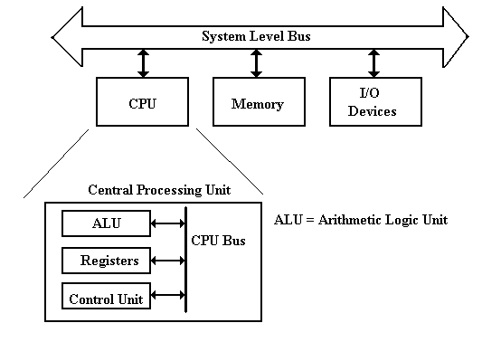
Figure: Top-Level Structure of a Computer

The functions of the three top-level components of a computer seem to be obvious. The I/O devices allow for communication of data to other devices and the users. The memory stores both program data and executable code in the form of binary machine language. The CPU comprises components that execute the machine language of the computer. Within the CPU, it is the function of the control unit to interpret the machine language and cause the CPU to execute the instructions as written. The Arithmetic Logic Unit (ALU) is that component of the CPU that does the arithmetic operations and the logical comparisons that are necessary for program execution. The ALU uses a number of local storage units, called registers, to hold results of its operations. The set of registers is sometimes called the register file.

Fetch-Execute Cycle
As we shall see, the fetch-execute cycle forms the basis for operation of a stored-program computer. The CPU fetches each instruction from the memory unit, then executes that instruction, and fetches the next instruction. An exception to the “fetch next instruction” rule comes when the equivalent of a Jump or Go To instruction is executed, in which case the instruction at the indicated address is fetched and executed.

Registers vs. Memory
Registers and memory are similar in that both store data. The difference between the two is somewhat an artifact of the history of computation, which has become solidified in all current architectures. The basic difference between devices used as registers and devices used for memory storage is that registers are usually faster and more expensive (see below for a discussion of registers and Level–1 Cache).

The origin of the register vs. memory distinction can be traced to two computers, each of which was built in the 1940’s: the ENIAC (Electronic Numerical Integrator and Calculator – becoming operational in 1945) and the EDSAC (Electronic Delay Storage Automatic Calculator – becoming operational in 1949). Each of the two computers could have been built with registers and memory implemented with vacuum tubes – a technology current and well-understood in the 1940’s. The difficulty is that such a design would require a very large number of vacuum tubes, with the associated cost and reliability problems. The ENIAC solution was to use vacuum tubes in design of the registers (each of which required 550 vacuum tubes) and not to have a memory at all. The EDSAC solution was to use vacuum tubes in the design of the registers and mercury delay lines for the memory unit.

In each of the designs above, the goal was the same – to reduce the number of “storage units” that required the expensive and hard-to-maintain vacuum tubes. This small number of storage units became the register file associated with the central processing unit (CPU). It was not until the MIT Whirlwind in 1952 that magnetic core memory was introduced.

In modern computers, the CPU is usually implemented on a single chip. Within this context, the difference between registers and memory is that the registers are on the CPU chip while most memory is on a different chip. Now that L1 (level 1) caches are appearing on CPU chips (all Pentium™ computers have a 32 KB L1 cache), the main difference between the two is the method used by the assembly language to access each. Memory is accessed by address as if it were in the main memory that is not on the chip and the memory management unit will map the access to the cache memory as appropriate. Register memory is accessed directly by specific instructions. One of the current issues in computer design is dividing the CPU chip space between registers and L1 cache: do we have more registers or more L1 cache? The current answer is that it does not seem to make a difference.

Both memory and registers can be viewed as collections of D flip-flops, as discussed in a previous chapter. The main difference is that registers (as static memory) may actually be built from these flip-flops, while computer memory is fabricated from a different technology called dynamic memory. We often describe main memory as if it were fabricated from flip-flops as this leads to a model that is logically correct.
A flip-flop stores one bit of data. An N–bit register is a collection of N flip-flops; thus a
32–bit register is built from 32 flip-flops. The CPU contains two types of registers, called special purpose registers and general purpose registers. The general purpose registers contain data used in computations and can be accessed directly by the computer program. The special purpose registers are used by the control unit to hold temporary results, access memory, and sequence the program execution. Normally, with one now-obsolete exception, these registers cannot be accessed by the program.

The program status register (PSR), also called the program status word (PSW), is one of the special purpose registers found on most computers. The PSR contains a number of bits to reflect the state of the CPU as well as the result of the most recent computation. Some of the common bits are
C the carry-out from the last arithmetic computation
V Set to 1 if the last arithmetic operation resulted in an overflow
N Set to 1 if the last arithmetic operation resulted in a negative number
Z Set to 1 if the last arithmetic operation resulted in a zero
I Interrupts enabled (Interrupts are discussed later)

More on the CPU (Central Processing Unit)
The central processing unit contains four major elements
1) The ALU (Arithmetic Logic Unit), and
2) The control unit, and
3) The register file (including user registers and special-purpose registers), and
4) A set of buses used for communications within the CPU.

The next figure shows a better top-level view of the CPU, showing three data buses and an ALU optimized for standard arithmetic. Most arithmetic (consider addition: C = A + B) is based on production of a result from two arguments. To facilitate such operations, the ALU is designed with two inputs and a single output. As each input and output must be connected to a bus internal to the CPU, this dictates at least three internal CPU buses.

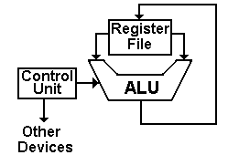

The register file contains a number of general-purpose registers accessible to the assembly language operations (often numbered 0 through some positive integer) and a number of special-purpose registers not directly accessed by the program. With numbered registers (say R0 through R7) it is often convenient to have R0 be identically 0. Such a constant register greatly simplifies the construction of the control unit.
Some of the special purpose registers used by the central processing unit are listed next.
PC the program counter contains the address of the assembly language instruction
to be executed next.
IR the instruction register contains the binary word corresponding to the machine
language version of the instruction currently being executed.
MAR the memory address register contains the address of the word in main memory
that is being accessed. The word being addressed contains either data or
a machine language instruction to be executed.
MBR the memory buffer register (also called MDR for memory data register) is the
register used to communicate data to and from the memory.

We may now sketch some of the operation of a typical stored program computer.
Reading Memory First place an address in the MAR.
Assert a READ control signal to command memory to be read.
Wait for memory to produce the result.
Copy the contents of the MBR to a register in the CPU.

Writing Memory First place and address in the MAR
Copy the contents of a register in the CPU to the MBR.
Assert a WRITE control signal to command the memory.

We have mentioned the fetch-execute cycle that is common to all stored program computers. We may now sketch the operation of that cycle
Copy the contents of the PC into the MAR.
Assert a READ control signal to the memory.
While waiting on the memory, increment the PC to point to the next instruction
Copy the MBR into the IR.
Decode the bits found in the IR to determine what the instruction says to do.

The control unit issues control signals that cause the CPU (and other components of the computer) to fetch the instruction to the IR (Instruction Register) and then execute the actions dictated by the machine language instruction that has been stored there. One might imagine the following sequence of control signals corresponding to the instruction fetch.

T0: PC to Bus1, Transfer Bus1 to Bus3, Bus3 to MAR, READ.
T1: PC to Bus1, +1 to Bus2, Add, Bus3 to PC.
T2: MBR to Bus2, Transfer Bus2 to Bus3, Bus3 to IR.

This simple sequence introduces a number of concepts that will be used later.
1. The internal buses of the CPU are named Bus1, Bus2, and Bus3.
2. All registers can transfer data to either Bus1 or Bus2.
3. Only Bus3 can transfer data into a register.
4. Only the ALU can transfer data from either Bus1 to Bus3 or Bus2 to Bus3.
It does this by a specific transfer operation.
5. Control signals are named for the action that they cause to take place.
Operation of the Control Unit
We now examine very briefly the two most common methods for building a control unit. Recall that the only function of the control unit is to emit control signals, so that the design of a control unit is just an investigation of how to generate control signals. There are two major classes of control units: hardwired and microprogrammed (or microcoded). In order to see the difference, let’s write the above control signals for the common fetch sequence in a more compact notation.
T0: PC → Bus1, TRA1, Bus3 → MAR, READ.
T1: PC → Bus1, +1 → Bus2, ADD, Bus3 → PC.
T2: MBR → Bus2, TRA2, Bus3 → IR.
Here we have used ten control signals. Remember that the ALU has two inputs, one from Bus1, one from Bus2, and outputs its results on Bus3. The control signals used are:
PC → Bus1 Copy the contents of the PC (Program Counter) onto Bus1
+1 → Bus2 Copy the contents of the constant register +1 onto Bus2.
MBR → Bus2 Copy the contents of the MBR (Memory Buffer Register) onto Bus2
TRA1 Causes the ALU to copy the contents of Bus1 onto Bus3
TRA2 Causes the ALU to copy the contents of Bus2 onto Bus3
ADD Causes the ALU to add the contents of Bus1 and Bus2,
placing the sum onto Bus3.
READ Causes the memory to be read and place the results in the MBR
Bus3 → MAR Copy the contents of Bus3 to the MAR (Memory Address Register)
Bus3 → PC Copy the contents of Bus3 to the PC (Program Counter)
Bus3 → IR Copy the contents of Bus3 to the IR (Instruction Register)
All control units have a number of important inputs, including the system clock, the IR, the PSR (program status register) and other status and control signals. A hardwired control unit uses combinational logic to produce the output. The following shows how the above signals would be generated by a hardwired control unit.

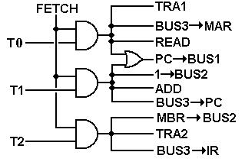
Here we assume that we have the discrete signal FETCH, which is asserted during the fetch phase of the instruction processing, and discrete time signals T0, T1, and T2, which would be generated by a counter within the control unit. Note here that we already have a naming problem: there will be a distinct phase of the Fetch/Execute cycle called “FETCH”. During that cycle, the discrete signal FETCH will be active. This discrete signal is best viewed as a Boolean value, having only two values: Logic 1 (+5 volts) and Logic 0 (0 volts).
We next consider how a microprogrammed unit would generate the above signals. In this discussion, we shall present a simplified picture of such a control with a number of design options assumed; these will be explained later in the text.

The central part of a microprogrammed control unit is the micro-memory, which is used to store the microprogram (or microcode). The microprogram essentially interprets the machine language instructions in that it causes the correct control signals to be emitted in the correct sequence. The microprogram, written in microcode, is stored in a read-only memory (ROM, PROM, or EPROM), which is often called the control store.

A microprogrammed control unit functions by reading a sequence of control words into a microinstruction buffer that is used to convert the binary bits in the microprogram into control signals for use by the CPU. To do this, there are several other components
the μMAR the micro-address of the next control word to read
the μMBR this holds the last control word read from the micro-memory
the sequencer this computes the next value of the address for the μMAR.

The figure below shows the structure of a sample microprogrammed control unit.

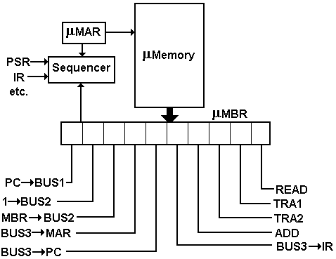

The microprogram for the three steps in fetch would be
10010 00011
11001 01000
00100 10100

The Pipelined CPU
Pipelining is a technique that allows multiple instructions to be in execution at the same time within the CPU. Some of the techniques used, such as instruction pre–fetching, date back to the development of the IBM Stretch (7030) in the early 1950’s. While it is possible that most of the theory of pipelining was developed that early, it was not until the arrival of VLSI chips with their excess of transistors that pipelining really became effective.
While the design is called “pipelining”, it really ought to be called “assembly lining”, because an instruction pipeline resembles nothing so much as the assembly line in an automobile plant. At each stage in an automobile assembly line, a distinct operation is performed on the car assembly, leading at the end to a complete automobile. In a CPU pipeline, the execution of an instruction is broken into primitive steps that are assigned to independent units.
The Assembly Line
Here is a picture of the Ford assembly line in 1913. It is the number of cars per hour that roll off the assembly line that is important, not the amount of time taken to produce any one car.
Henry Ford began working on the assembly line concept about 1908 and had essentially
perfected the idea by 1913. His motivations are worth study. In earlier years, automobile manufacture had been done by highly skilled technicians, each of whom assembled the whole car. It occurred to Mr. Ford that he could get more get more workers if he did not require such a high skill level. One way to do this was to have each worker perform only a small
number of tasks related to manufacture of the entire automobile. It soon became obvious that is was easier to bring the automobile to the worker than have the worker (and his tools) move to the automobile. The CPU pipeline has a number of similarities.
1. The execution of an instruction is broken into a number of simple steps, each
of which can be handled by an efficient execution unit.
2. The CPU is designed so that it can simultaneously be executing a number of
instructions, each in its own distinct phase of execution.
3. The important number is the number of instructions completed per unit time,
or equivalently the instruction issue rate.
The MIPS Pipeline
The best way to discuss the pipeline idea is to show a sample high–level diagram. This is the pipeline for the MIPS (Microprocessor without Interlocked Pipeline Stages [R105]) that was developed in 1981 by a team at Stanford University lead by John L. Hennessy. Our description of the CPU for the MIPS comes from the standard text by Patterson and Hennessy [R80]; the second author was the one who lead the development team.
The MIPS pipeline design is based on the five–step instruction execution discussed; the pipeline will have five stages, with one stage for each step in the execution of a typical instruction.
1. IF: Fetch instruction from memory.
2. ID: Decode the instruction and read two registers.
3. EX: Execute the operation or calculate an address.
4. MEM: Access an operand in data memory or write back a result.
5. WB: For LW (load word) only, write the results of the memory read into a register.
Here is a figure, taken from [R80] to illustrate the MIPS pipeline. It shows the execution pipeline broken into five stages, with additional register sets inserted between the stages. Thus, we have the IF/ID (Instruction Fetch / Instruction Decode) register set between the first two stages. Note also, the three ALUs; two extra are required to support pipelining. One should consider the instructions as moving from left to right in this pipeline; those to the right are in a more advanced stage of execution.
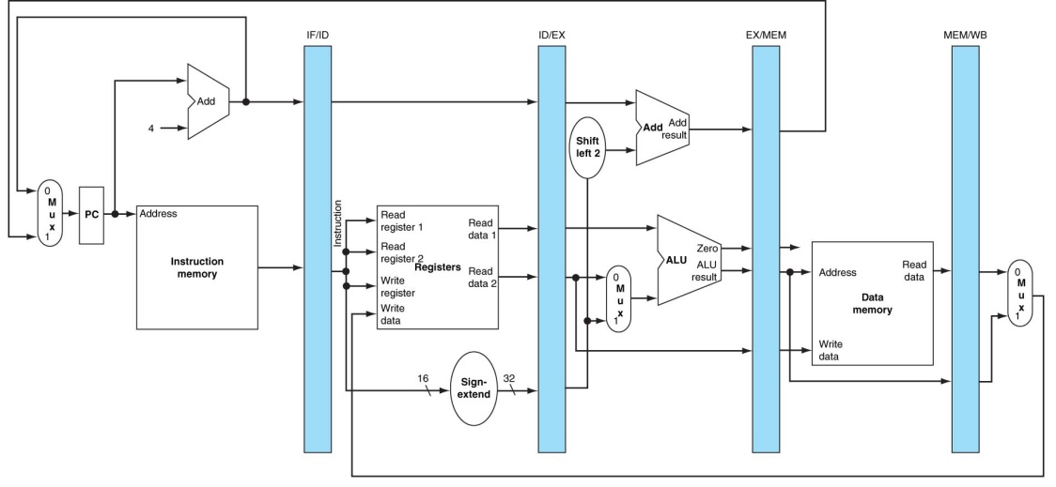
A fuller explanation of this figure will be given in the graduate course on computer architecture. The only reason for showing it here is to make two points.
1. The execution of an instruction can be broken into sequential stages.
2. There is additional hardware required to support pipelining.
As a design feature, pipelining is similar to very many enhancements. If added “after the fact”, it will be very hard to implement correctly. It is much better to design the ISA (Instruction Set Architecture) with pipelining in mind. This brings home a very important feature of design: the compilers, operating system, ISA, and hardware implementation must all be designed at the same time. Put another way, the system must be designed as a whole, with appropriate trade–offs between subsystems in order to optimize the overall performance.

Features of the MIPS design that were intended to facilitate pipelining include:
1. The fact that all instructions are the same length.
2. The small number of instruction formats.
3. The regularity of the instruction format, always beginning with a 6–bit opcode,
followed by two 5–bit register identifiers.
4. The use of the load/store design, restricting memory accesses to
only two, well defined, steps.
5. The fact that only one instruction writes to memory and that as the last stage in
instruction execution. This has major impact on the design to handle interrupts,
especially the page–fault interrupts generated by a virtual memory system.
Many of these features are precisely those that characterize a RISC design, as discussed later in this chapter. In fact, the MIPS is properly called a RISC architecture. The reader is advised to consult with the referenced textbook [R80] for more details on this design.
In order to discuss the operation of the pipeline and focus on the difficulties associated with a correct pipeline design, we focus on a five–line fragment of MIPS assembly language.
SUB $2, $1, $3 # The “$” denotes a register. $2
AND $12, $2, $5 # is register 2 in the register file.
OR $13, $6, $2 # Note that $2 is used in each line.
ADD $14, $2, $2 # 100($2) is an address calculation.
SW $15, 100($2) # Add 100 to contents of $2.
Ideally a pipelined CPU should function in much the same way as an automobile assembly line; each stage operates in complete independence of every other stage. The instruction is issued and enters the pipeline. It then moves through each of the execution stages, until it is completed and exits the pipeline. The next table shows the stage of execution for each of the five instructions above for each clock cycle. In clock cycle 5, the SUB instruction is in WB, the AND instruction is in MEM, etc.
Time (Clock Cyles) | CC1 | CC2 | CC3 | CC4 | CC5 | CC6 | CC7 | CC8 | CC9
SUB $2, $1, $3 | IF | ID | EX | MEM | WB
AND $12, $2, $5 |  | IF | ID | EX | MEM | WB
OR $13, $6, $2 |  |  | IF | ID | EX | MEM | WB
ADD $14, $2, $2 |  |  |  | IF | ID | EX | MEM | WB
SW $15, 100($2) |  |  |  |  | IF | ID | EX | MEM | WB
Another way to look at this is ordered by clock pulse and shows what four of the five stages in the pipeline is doing at any given time. WB is omitted to keep the table readable.
CC | IF | ID | EX | MEM
1 | SUB $2, $1, $3 | An earlier instruction. | An earlier instruction. | An earlier instruction.
2 | AND $12, $2, $5 | SUB $2, $1, $3 | An earlier instruction. | An earlier instruction.
3 | OR $13, $6, $2 | AND $12, $2, $5 | SUB $2, $1, $3 | An earlier instruction.
4 | ADD $14, $2, $2 | OR $13, $6, $2 | AND $12, $2, $5 | SUB $2, $1, $3
5 | SW $15, 100($2) | ADD $14, $2, $2 | OR $13, $6, $2 | AND $12, $2, $5

We can use either of these two tables to examine the progression of instructions through the execution pipeline. Ideally, as an instruction progresses through the pipeline it does not depend on the results of any other instruction now in the pipeline. Obviously, this cannot always be the case; in our example above, it is not the case.
There is one absolute requirement for correct operation of a pipeline. We use the above code fragment to illustrate this requirement.
SUB $2, $1, $3
AND $12, $2, $5
OR $13, $6, $2
ADD $14, $2, $2
SW $15, 100($2)
The effect of executing this code must be the same as it would have been had the code been executed on a simple non–pipelined CPU. In particular, the value in register $2, computed in the first instruction, must be the value used in all following instructions. Suppose that the effect of the SUB instruction is to change the value stored in $2 from 10 to –20. The next four instructions must use this new value, not the older value of +10.
What can we say that will always be true about pipelined execution?
1. It is not possible for any instruction to depend on the results of instructions
that will execute in the future. This is a logical impossibility.
2. Instructions can have dependence only on those previously executed; however,
there are no issues associated with dependence on instructions that have completed
execution and exited the pipeline. Results of these instructions have been stored in
either the memory or register file, and are available for immediate use.
3. It is possible, and practical, to design a compiler that will minimize problems in
the pipeline. This is a desirable result of the joint design of compiler and ISA.
4. It is not possible for the compiler to eliminate all pipelining problems without
reducing the CPU to a non–pipelined datapath, which is unacceptably slow.
A pipeline hazard occurs when an instruction cannot complete a step in its execution, due to some event in the previous clock cycle. When an instruction must be held for one or more clock pulses in order to complete a step in its execution, this is called a “pipeline stall”, informally a “bubble”. These pipeline problems are called hazards. They come in three varieties: structural hazards, data hazards, and control hazards. Structural hazards occur when the instruction set architecture does not match the design of the control unit. In other words, the hardware cannot support the combination of instructions that we want to execute in the same clock cycle. Careful design can eliminate this type of problem.
Data hazards are due to tight dependencies in sequences of machine language instructions. These occur when one step in the pipeline must await the completion of a previous instruction. A good compiler can reduce these hazards, but not eliminate them. Our example code section above illustrates a typical data hazard.

The next figure, taken from [R80] assumes that the effect of the first instruction is to change the contents of register $2 from 10 to –20. This result is not available in the register file until the first half of CC 5; thus the two instructions (AND, OR) following the first get bad values.
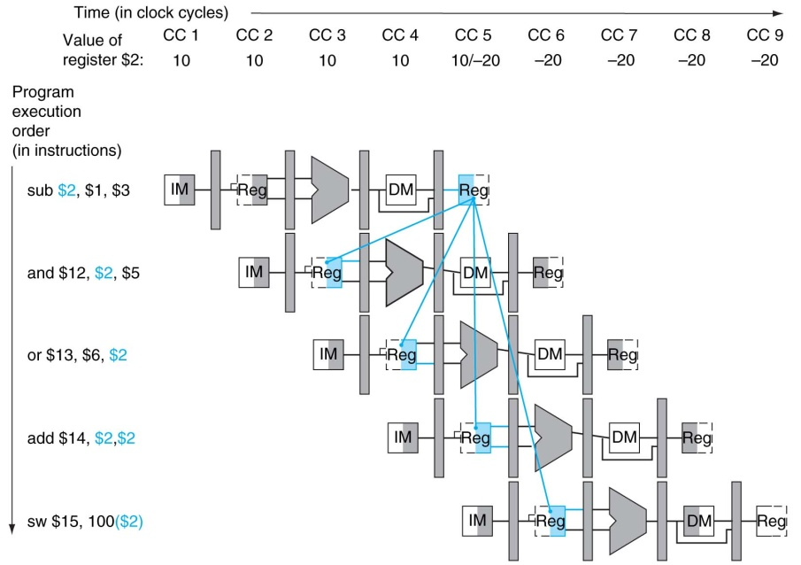
Control hazards, also called branch hazards, arise from the need to make a decision based on the results of one instruction while others are executing. A typical example would be the execution of a conditional branch instruction. If the branch is taken, the instructions currently in the pipeline might be invalid. As an example, consider the following execution flow which has no data hazards.
The instruction at address 40 is in the Execution stage of the datapath,
The instruction at address 44 is in the Instruction Decode stage, and
The instruction at address 48 is in the Instruction Fetch stage.
The MIPS is a byte–addressable machine, with 32–bit instructions. The address of the instruction after that at 40 is 44. When the BEQ executes, the PC already has value 44. The branch target address is the value 7 multiplied by 4 and added to the PC; 4•7 + 44 = 72.
40 BEQ $1, $3, 7 # Branch if ($1 == $3)
44 AND $12, $2, $5
48 OR $13, $6, $2
52 ADD $14, $2, $2
72 LW $4, 50($7)
There are two possible outcomes for the execution of the BEQ:
1. The branch is not taken. Execution proceeds without delay.
2. The branch is taken. The partially executed instructions at addresses 44 and 48 must
be removed from the pipeline without having changed the machine state.
A more thorough discussion of pipelining, pipeline hazards, and the remedies to those hazards would be interesting but take too much time. This textbook requires a knowledge of what a data hazard is, because they are considered in the design of some supercomputers.
Levels of Machines and Virtual Machines
As with any system, a computer can be viewed from a number of perspectives or levels of detail. Each level corresponds to a virtual machine – one able to execute directly a specific language. For example, many people view computers as virtual machines that directly execute e-mail programs, spread sheets, or word processors. These people do not care about the lower level instructions that actually cause the machine to function, nor should they.

Put another way, many people consider the computer as just another appliance – that is, something that does its job with little human interaction. In this author’s opinion, this fact is one of the major achievements of the computer industry.

“Levels” of Automobiles
In order to motivate the idea of levels of machines, let us consider what might be called “levels of automobiles” or more precisely, the level of detail at which a particular user chooses to understand an automobile. As an example, let us think about the Rolls Royce Phantom (the 2004 model is priced at only $470,000, in case you want to buy one). There are a number of levels at which to view this automobile.

The automobile collector will view the car as a work of art. The possibility that one might drive the thing might not even occur to him or her.

The VIP (very rich person or diplomat) will view the automobile as something that transports him or her to the desired destination. Admittedly, the automobile does not drive itself, but it might as well, given the fact that it almost always has a paid chauffeur.

The casual driver will understand the basics of operating the vehicle – use of the keys, transmission, steering wheel, and other controls. To this person, the automobile is just a machine that can be controlled in predictable ways.

The more involved driver will, in addition, understand that the automobile comprises a number of subsystems, such as the chassis, engine, transmission, and electronic systems. He or she will understand the necessity of system maintenance without being able to perform it.

The automobile mechanic will understand the details of each of the automobile subsystems and how to repair them. Note that this is a lower (more detailed) level of understanding than the involved driver. The mechanic not only understands that the subsystems exist but also understands how they work and how to fix them.

The automobile engineer will understand one of the subsystems in detail, for example the detailed kinetics of fuel combustion, metallurgy of the engine block, or dynamics of the electrical system.

Using this analogy, the goal of this course is to give the student an understanding of a computer somewhere between that of a mechanic and an engineer.

Levels of Machines in the Computer Hierarchy
A traditional view of the computer (see Tanenbaum [R15] or Murdocca & Heuring [R16]) presents between five and eight levels of machines. Here we construct a typical list.

9. Application Programs (Appliance level),
8. High Level (Problem Oriented) Languages,
7. Assembly language,
6. Operating system services (such as BIOS calls)
5. Binary machine language,
4. Micro-operation level (usually microprogramming),
3. Functional units (memory, ALU, etc.)
2. Logic gates, including SSI and MSI components.
1. Transistors and wires.

We skip over level 9 (application programs) and begin our top-down study with level 8 (High Level Languages). A high-level language programmer may experience the computer as a machine that directly executes the high-level language, such as C++, Visual Basic, COBOL, or FORTRAN. In fact, very few machines are designed for direct execution of high-level languages (there are several LISP machines and a FORTH machine), but one may imagine a virtual machine that does exactly that. In practice, most virtual machines operating at the high-level language level achieve their effect by compiling the program into a form suitable for execution on a lower-level machine. The figure below shows two of the more common ways in which a high-level language virtual machine functions.

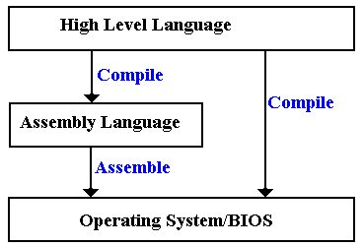

Before discussing this figure, it is important to understand the differences between level 6 (the Operating System/BIOS level) and level 5 (the Binary Machine Language level). In some aspects, levels 5 and 6 are identical. The major difference is that level 6 may be regarded as providing standard service routines, such as those in the Basic Input-Output System (BIOS). The operating code for both levels 5 and 6 is binary machine code.

Some compilers (mainly the older ones) compile directly to assembly language, which is then assembled into calls to level 6 machine language. Some compile directly to level 6 code.
At this point, we see an important part of the separation of levels. Consider modern languages, such as C++ and Java. At level 8, all computers that execute such code appear to be almost identical, with slight differences (such as integer sizes) that can be handled by use of macros and other definitions. At level 7, the computers may appear quite different as each computer brand seems to have its own particular assembly language.

The transition between levels 6 and 7 (assembly language & O/S services) and level 5 is often achieved by a linking loader. This transition allows programs to be loaded at any free part of memory, rather than at fixed locations (as was the case with some earlier machines). Thus we have two views of machines – the level 6/7 virtual machine in which the program always loads at a fixed location and the level 5 machine in which the program is relocated.

The split between levels 5 and 4 reflects the fact that there are a number of ways in which to implement a Central Processing Unit (CPU) to execute a machine language. The two primary methods for machine language execution are hard-wired and microprogrammed. This separation between these two levels allows a company to build a series of computers with widely differing performance levels but with the same assembly/machine language set. For examples, we look to the IBM 360 series and the DEC (Digital Equipment Corporation – no longer in business) PDP–11 series.

Here is a quote from an article by C. Gordon Bell in William Stallings []. It discusses two different implementations of the IBM 360 family, each with the same assembly language.

“The IBM 360, introduced in 1964, was one of the earliest computer families to span a range of price and performance. Along with the 360, IBM introduced the word ‘architecture’ to refer to the various processing characteristics of a machine as seen by the programmer and his programs. In the initial 360 product family, the model 91 exceeded the model 20 in performance by a factor of 300, in memory size by a factor of 512, and in price by a factor of 100.”

The next three layers form the basis for the hardware implementation of the computer. As technology improves, we see two trends in implementation at this level: more powerful units for the same price and equally powerful units for a lesser price. One very early example of this was the IBM 709/7090 series, both of which implemented the same machine language and used the same hardwired control design. The difference is that the IBM 709 used vacuum tubes as the basic circuit elements, while the IBM 7090 used transistors.

Probably the major revolution in computer design occurred at these low levels with the introduction to the integrated circuit to replace circuits built from discrete transistors. The transition from vacuum tubes to transistors resulted in considerable gains in reliability and reductions in power usage. The transition from transistors to integrated circuits, especially VLSI (Very Large Scale Integration) chips allowed the introduction of the modern micro-computer and all that has gone with it.

RISC vs. CISC Computers
One of the recent developments in computer architecture is called by the acronym RISC. Under this classification, a design is either RISC or CISC, with the following definitions.
RISC Reduced Instruction Set Computer
CISC Complex Instruction Set Computer.

The definition of CISC architecture is very simple – it is any design that does not implement RISC architecture. We now define RISC architecture and give some history of its evolution.
The source for these notes is the book Computer Systems Design and Architecture, by Vincent P. Heuring and Harry F. Jordan [R03].

One should note that while the name “RISC” is of fairly recent origin (dating to the late 1970’s) the concept can be traced to the work of Seymour Cray, then of Control Data Corporation, on the CDC–6600 and related machines. Mr. Cray did not think in terms of a reduced instruction set, but in terms of a very fast computer with a well-defined purpose – to solve complex mathematical simulations. The resulting design supported only two basic data types (integers and real numbers) and had a very simple, but powerful, instruction set. Looking back at the design of this computer, we see that the CDC–6600 could have been called a RISC design.

As we shall see just below, the entire RISC vs. CISC evolution is driven by the desire to obtain maximum performance from a computer at a reasonable price. Mr. Cray’s machines maximized performance by limiting the domain of the problems they would solve.

The general characteristic of a CISC architecture is the emphasis on doing more with each instruction. This may involve complex instructions and complex addressing modes; for example the MC68020 processor supports 25 addressing modes.

The ability to do more with each instruction allows more operations to be compressed into the same program size, something very desirable if memory costs are high. Some historical data will illustrate the memory issue. Better cost data are found in the chapter on memory.

Time | Cost of memory | Cost of disk drive
Introduction of MC6800 | $500 for 16KB RAM | $55,000 for 40 MB
Introduction of MC68000 | $200 for 64 KB RAM | $5,000 for 10 MB
Now (Micron 4/10/2002) | $49 for 128 MB RAM | $149 for 20 GB

Another justification for the CISC architectures was the “semantic gap”, the difference between the structure of the assembly language and the structure of the high level languages (COBOL, C++, Visual Basic, FORTRAN, etc.) that we want the computer to support. It was expected that a more complicated instruction set (more complicated assembly language) would more closely resemble the high level language to be supported and thus facilitate the creation of a compiler for the assembly language.

One of the first motivations for the RISC architecture came from a careful study of the implications of the semantic gap. Experimental studies conducted in 1971 by Donald Knuth and 1982 by David Patterson showed that nearly 85% of a programs statements were simple assignment, conditional, or procedure calls. None of these required a complicated instruction set. It was further notes that typical compilers translated complex high level language constructs into simpler assembly language statements, not the complicated assembly language instructions that seemed more likely to be used.

The results of this study are quoted from an IEEE Tutorial on RISC architecture [R05]. This table shows the percentages of program statements that fall into five broad classifications.

Language | Pascal | FORTRAN | Pascal | C | SAL
Workload | Scientific | Student | System | System | System
Assignment | 74 | 67 | 45 | 38 | 42
Loop | 4 | 3 | 5 | 3 | 4
Call | 1 | 3 | 15 | 12 | 12
If | 20 | 11 | 29 | 43 | 36
GOTO | 2 | 9 | -- | 3 | --
Other |  | 7 | 6 | 1 | 6

The authors of this study made the following comments on the results.

“There is quite good agreement in the results of this mixture of languages and applications. Assignment statements predominate, suggesting that the simple movement of data is of high importance. There is also a preponderance of conditional statements (If, Loop). These statements are implemented in machine language with some sort of compare and branch instruction. This suggests that the sequence control mechanism is important.”

The “bottom line” for the above results can be summarized as follows.
1) As time progresses, more and more programs will be written in a compiled high-
level language, with much fewer written directly in assembly language.
2) The compilers for these languages do not make use of the complex instruction
sets provided by the architecture in an attempt to close the semantic gap.

In 1979, the author of these notes attended a lecture by a senior design engineer from IBM. He was discussing a feature of an architecture that he designed: he had put about 6 months of highly skilled labor into implementing a particular assembly language instruction and then found that it was used less than 1/10,000 of a percent of the time by any compiler.

So the “semantic gap” – the desire to provide a robust architecture for support of high-level language programming turned out to lead to a waste of time and resources. Were there any other justifications for the CISC design philosophy?

The other motivation for the RISC architecture is that a complex instruction set implies a slower computer. It is not just the fact that the more complex instructions execute more slowly than the simpler instructions. There is also the fact that making a CPU capable of handling more complex instructions causes it to execute simple instructions more slowly.

Thus we are facing the facts that the more complex instruction sets are not necessary and that dropping the ability to support them will yield a faster CPU. There are other factors that favor the RISC architecture, specifically the fact that speed-up techniques such as instruction pre-fetching and instruction pipelining are more easily achieved for simple instructions.

The name RISC, Reduced Instruction Set Computer, focuses on reducing the number and complexity of instructions in the machine. A number of common strategies are:
1) Fixed instruction length, generally one word. This simplifies instruction fetch.
2) Simplified addressing modes.
3) Fewer and simpler instructions in the instruction set.
4) Only load and store instructions access memory; no add memory to register, etc.
5) Let the compiler do it. Use a good compiler to break complex high-level language
statements into a number of simple assembly language statements.

The philosophy behind the RISC approach is well described in the IEEE tutorial. Here we pick up on a narrative by a design engineer who worked on the IBM 801 project.

“About this point, several people, including those who had been working on microprogramming tools, began to rethink the architectural design principles of the 1970’s. In trying to close the ‘semantic gap’, these principles had actually introduced a ’performance gap’. The attempt to bridge the gap with WCS’s [Writable Control Stores – microprogrammed control units] was unsuccessful.”

“A new computer design philosophy evolved: Optimizing compilers could be used to compile ‘normal’ programming languages down to instructions that were as unencumbered as microinstructions in a large virtual address space, and to make the instruction cycle time as fast as the technology would allow. These machines would have fewer instructions – a reduced set – and the remaining instructions would be simple and would generally execute in one cycle – reduced instructions – hence the name reduced instruction set computers (RISC’s). RISC’s inaugurated a new set of architectural design principles.
1. Functions should be kept simple unless there is a very good reason to do
otherwise.
2. Microinstructions should not be faster than simple instructions.
3. Microcode is not magic.
4. Simple decoding and pipelined execution are more important than
program size.
5. Compiler technology should be used to simplify instructions rather
than to generate complex instructions.”
The narrative from the tutorial continues with remarks on the RISC architectures developed at the University of California at Berkeley.

“Although each project [the Berkeley RISC I and RISC II and the IBM 801] had different constraints and goals, the machines they eventually created have a great deal in common.
1. Operations are register-to-register, with only LOAD and STORE
accessing memory.
2. The operations and addressing modes are reduced. Operations between registers complete in one cycle, permitting a simpler, hardwired control for each RISC, instead of microcode. Multiple-cycle instructions such as floating-point arithmetic are either executed in software or in a special-purpose processor. (Without a coprocessor, RISC’s have mediocre floating-point performance.) Only two simple addressing modes, indexed and PC-relative, are provided. More complicated addressing modes can be synthesized from the simple ones.
3. Instruction formats are simple and do not cross word boundaries. This restriction allows RISC’s to remove instruction decoding time from the critical execution path. … RISC register operands are always in the same place in the
32-bit word, so register access can take place simultaneously with opcode decoding. This removes the instruction decoding stage from the pipelined execution, making it more effective by shortening the pipeline.”

There are a number of other advantages to the RISC architecture. We list a few

Better Access to Memory
According to the IEEE Tutorial
“Register-oriented architectures have significantly lower data memory bandwidth. Lower data memory bandwidth is highly desirable since data access is less predictable than instruction access and can cause more performance problems.”

We note that, even at 6.4 GB/second data transfer rates, access to memory is still a bottleneck in modern computer design, so any design that reduces the requirement for memory access (here called reducing the memory bandwidth) would be advantageous.

Better Support of Compilers
According to the IEEE Tutorial
“The load/store nature of these [existing RISC] architectures is very suitable for effective register allocation by the compiler; furthermore, each eliminated memory reference results in saving an entire instruction.”

We note here that more effective register allocation by a compiler will usually result in faster-running code. We see this as another advantage of the RISC design.

The Dynamic–Static Interface
In order to understand the DSI, we must place it within the context of a compiler for a higher–level language. Although most compilers do not emit assembly language, we shall find it easier to under the DSI if we pretend that they do.
What does the compiler output? There are two options:
1. A very simple assembly language. This requires a sophisticated compiler.
2. A more complex assembly language. This may allow a simpler compiler,
but it requires a more complex control unit.
The DSI really defines the division between what the compiler does and what the microarchitecture does. The more complexity assigned to the compiler, the less that is assigned to the control unit, which can be simpler, faster, and smaller.
One should put the DSI conversation within the context of the fact that we have become very good at writing efficient compilers. This is especially true in management of the register file, as well as identifying code segments that can be run in parallel, were parallel execution units available. Some modern hardware architectures explicitly allow multiple instructions to be issued at once, but depend on the compiler to issue execution packets. While this grouping of instructions into execution packets could be done by hardware at execution time, that would lead to a great increase in hardware complexity.
Instruction Pre-Fetching
One advantage of the RISC architecture is seen in the process referred to as
instruction pre-fetching. In this process, we view the fetch-execute process as a pipeline.

In a traditional fetch-execute machine, the instruction is first fetched from memory and then executed. Very early in CPU design, it was recognized that the fetch unit should be doing something during the time interval for executing the instruction. The logical thing for the fetch unit to do was to fetch the instruction in the next memory location on the chance that it would be the instruction that would be executed next. This process has been shown to improve computer performance significantly. The logic to pre-fetch instructions is facilitated by the RISC design philosophy that all instructions are the same size, so in a machine based on 32-bit words the pre-fetch unit just grabs the next four bytes.

Instruction pre-fetching appears rather simple, except in the presence of program jumps, such as occur in the case of conditional branches and the end of program loops. A lot of work has gone into prediction of the next instruction in such cases, where there are two instructions that could be executed next depending on some condition. It may be possible to execute both candidate instructions and discard the result of the instruction not in the true execution path.

Implications for the Control Unit
The complex instructions in a CISC computer tend to require more support in the execution than can conveniently be provided by a hardwired control unit. For this reason, most CISC computers are microprogrammed to handle the complexity of each of the instructions. For this reason, most CISC instructions require a number of system clock cycles to execute. The RISC approach emphasizes use of a simpler instruction set that can easily be supported by a hardwired control unit. As a side effect, most RISC instructions can be executed in one clock cycle. A given computer program will compile into more RISC instructions than CISC instructions, but the CISC instructions execute more slowly than the RISC instructions. The overall effect on the computer program may be hard to predict. According to the tutorial
“Reducing the instruction set further reduces the work a RISC processor has to do. Since RISC has fewer types of instructions than CISC, a RISC instruction requires less processing logic to interpret than a CISC instruction. The effect of such simplification is to speed up the execution rate for RISC instructions. In a RISC implementation it is theoretically possible to execute an instruction each time the computer’s logic clock ticks. In practice the clock rate of a RISC processor is usually three times that of the instruction rate.”
We close this section by giving a comparison of some RISC and CISC computers and quoting some of the experience of the Digital Equipment Corporation when it tried to manufacture a RISC version of its Micro-VAX (a follow-on to the PDP-11). Here is the table, taken from the IEEE tutorial on RISC architecture.
 | CISC Type Computers |  |  | RISC Type
 | IBM 370/168 | VAX-11/780 | Intel 8086 | RISC I | IBM 801
Developed | 1973 | 1978 | 1978 | 1981 | 1980
Instructions | 208 | 303 | 133 | 31 | 120
Instruction size (bits) | 16 – 48 | 16 – 456 | 8 – 32 | 32 | 32
Addressing Modes | 4 | 22 | 6 | 3 | 3
General Registers | 16 | 16 | 4 | 138 | 32
Control Memory Size | 420 Kb | 480 Kb | Not given | 0 | 0
Cache Size | 64 Kb | 64 Kb | Not given | 0 | Not given
Note the control memory size on the two RISC type computers – each has no control memory. This implies that the control unit is purely hardwired. Experience in the 1980’s and early 1990’s suggested that microprogrammed control units were preferable, even if they were a bit slower than hardwired units. It was argued that the speed of the control unit was not the limiting factor in performance, and it probably was not. The plain fact, however, was that implementing a hardwired control unit for some of the complex instruction sets was a daunting challenge not willingly faced by the computer designers. Rather than spend a great fortune on designing, building, and debugging such a unit, they elected to create control units that could be managed – these were microprogrammed.
With the development of RISC architecture, hardwired control units again became feasible.

Another Look at Microprogrammed Control Units
In considering the RISC design, we should recognize the fact that it is not equivalent to use of a hardwired control unit; only more compatible with such a unit. Many modern control units might be considered as hybrid, with mostly hardwired control and provisions for the use of micro-routines (in microcode) to handle useful, but complex, instructions.

It has been hinted above that microprogramming has been used as a tool to allow feasible and cost-effective implementations of complex instruction sets. It is profitable to consider the correlation between complex instructions and the use of a microprogrammed control unit; specifically asking the question of the allocation of lines of microcode to assembly language instructions.
Digital Equipment Corporation (DEC) undertook an experiment to investigate this correlation and produced a design yielding interesting, but not surprising, results, which are again quoted from the IEEE tutorial on RISC architecture.
“DEC reported a subsetting experiment on two implementations of the VAX architecture in VLSI. The VLSI VAX has nine custom VLSI chips and implements the complete VAX-11 instruction set. DEC found that 20.0 percent of the instructions are responsible for 60.0 percent of the microcode and yet are only 0.2 percent of all instructions executed. By trapping to software to execute these instructions, the MicroVAX 32 was able to fit the subset architecture onto only one chip, with an optional floating-point processor on another chip. .. The VLSI VAX uses five to ten times the resources of the MicroVAX 32 to implement the full instruction set, yet is only 20 percent faster.”
 | VLSI VAX | MicroVAX 32
VLSI Chips | 9 | 2
Microcode | 480K | 64K
Transistors | 1250K | 101K
The result is obvious – a simple and cheaper computer will do most of what you want. The rest can be better done in software.
The RISC/370
This is your authors name for a hardware / software architecture developed by David A. Patterson [R104]. This experiment focused on the IBM S/360 and S/370 as targets for a
RISC compiler. One model of interest was the S/360 model 44. The S/360 model 44 implements only a subset of the S/360 architecture in hardware; the rest of the functions are implemented in software. This allows for a simpler and cheaper control unit. The Model 44 was marketed as a low–end S/360, less powerful and less costly.
A compiler created for the RISC computer IBM 801 was adapted to emit code for the S/370 treated as a register–to–register machine, in the style of a RISC computer. Only a subset of the S/370 instructions was used as a target for the compiler. Specifically, the type RX (memory and register) arithmetic instructions were omitted, as were the packed decimal instructions, all of which are designed to be memory to memory with no explicit register use.
This subset ran programs 50 percent faster than the previous best optimizing compiler that used the full S/370 instruction set. Possibly the S/370 was an overly complex design.
RISC vs. CISC: Final Comments
We give the final word on the RISC versus CISC controversy to William Stallings [R06], who ends his chapter on Reduced Instruction Set Computers with these comments.
“The work that has been done on assessing the merits of the RISC approach can be grouped into two categories. Quantitative: Attempts to compare program size and execution speed of programs on RISC and CISC machines that use comparable technology. Qualitative: Examines issues such as high–level language support and optimum use of VLSI real estate.”
“Most of the work on quantitative assessments has been done by those working on RISC systems … and it has been, by and large, favorable to the RISC approach.”
“There are several problems with attempting such comparisons.
1. There is no pair of RISC and CISC machines that are comparable in life–
cycle cost, level of technology, gate complexity, sophistication of
compiler, operating system support, and so on.
2. No definitive test set of programs exists. Performance varies with the
program.
3. It is difficult to sort out hardware effects from effects due to skill in
compiler writing.
4. Most of the comparative analysis of RISC has been done on toy machines
rather than commercial products. Moreover, most commercially available
machines advertised as RISC possess a mixture of RISC and CISC
characteristics. Thus, a fair comparison with a commercial ‘pure play’
CISC machine (e.g., VAX, Pentium) is difficult.” [R06]

